- Password reset link not working in user management when click on lock icon
http://209.97.146.230/billadacrm/users#
pdf page no.36
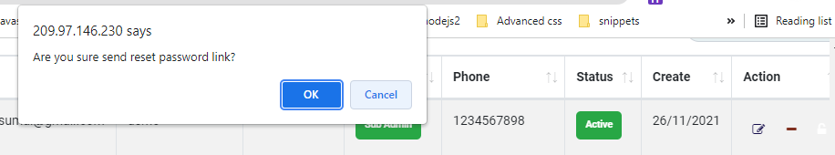
Report Management
- After click on search
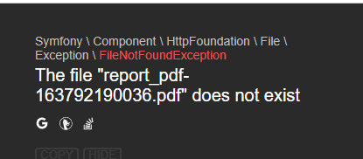
- After click on pdf
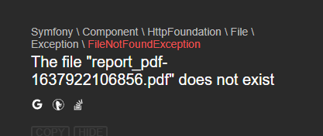
http://209.97.146.230/billadacrm/AgineBalance
http://209.97.146.230/billadacrm/OverdueTrend
http://209.97.146.230/billadacrm/DOC
http://209.97.146.230/billadacrm/TurnoverTotal
pdf page no.38 & page no.39 & page no.40 & page no.41
Invoice Management
This error came after click on pdf
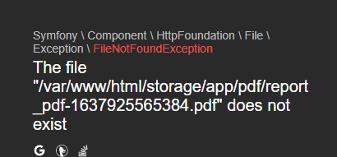
http://209.97.146.230/billadacrm/outstanding_first_report
http://209.97.146.230/billadacrm/outstanding_second_report
http://209.97.146.230/billadacrm/outstanding_third_report
http://209.97.146.230/billadacrm/outstanding_debt_report
http://209.97.146.230/billadacrm/paid_first_report
http://209.97.146.230/billadacrm/paid_second_report
http://209.97.146.230/billadacrm/paid_third_report
http://209.97.146.230/billadacrm/paid_debt_report
pdf page no.24 to 31

